Name: SMIRTI KUMARI

PRN: 1062233392

Division: Third

Class: FY MCA MANAGEMENT

**Web Technology Assignment**

Q1) Develop JavaScript code with POP-UP boxes and functions for the following problems:

 a) Input: Click on Display Date button using onclick() function

 Output: Display date in the textbox.

Solution:

<!DOCTYPE html>

<html lang="en">

<head>

    <meta charset="UTF-8">

    <meta name="viewport" content="width=device-width, initial-scale=1.0">

    <title>Display Date</title>

    <script>

        // Function to display the current date

        function displayDate() {

            // Create a new Date object

            var currentDate = new Date();

            // Get the current date, month, and year

            var day = currentDate.getDate();

            var month = currentDate.getMonth() + 1; // Month starts from 0

            var year = currentDate.getFullYear();

            // Format the date as yyyy-mm-dd

            var formattedDate = year + '-' + month + '-' + day;

            // Update the value of the textbox with the formatted date

            document.getElementById('dateInput').value = formattedDate;

        }

    </script>

</head>

<body>

    <h1>Display Date</h1>

    <!-- Button to trigger the displayDate function -->

    <button onclick="displayDate()">Display Date</button>

    <br><br>

    <!-- Textbox to display the date -->

    <input type="text" id="dateInput">

</body>

</html>

**OUTPUT:**

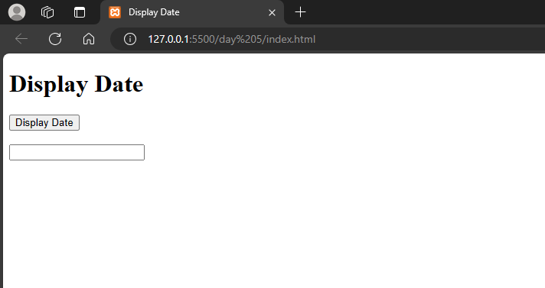

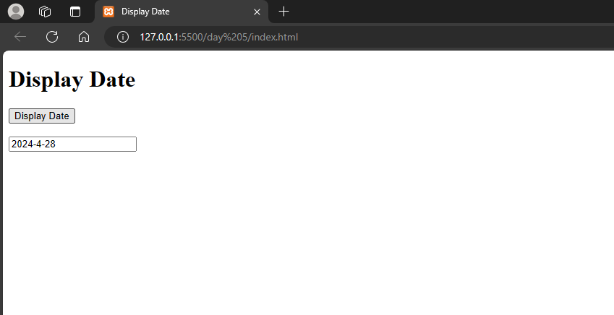

 b) Input: A number n obtained using prompt

 Output: Factorial of n number using alert.

Solution:

<!DOCTYPE html>

<html lang="en">

<head>

    <meta charset="UTF-8">

    <meta name="viewport" content="width=device-width, initial-scale=1.0">

    <title>Factorial Calculator</title>

    <script>

        // Function to calculate the factorial of a number

        function calculateFactorial() {

            // Get the input number from the user

            var n = prompt("Enter a number to calculate its factorial:");

            // Convert the input to a number

            n = parseInt(n);

            // Check if the input is a valid number

            if (!isNaN(n) && n >= 0) {

                // Calculate the factorial

                var factorial = 1;

                for (var i = 1; i <= n; i++) {

                    factorial *= i;

                }

                // Display the result using an alert

                alert("The factorial of " + n + " is: " + factorial);

            } else {

                // Display an error message if the input is not valid

                alert("Please enter a valid non-negative number.");

            }

        }

    </script>

</head>

<body>

    <h1>Factorial Calculator</h1>

    <!-- Button to trigger the calculateFactorial function -->

    <button onclick="calculateFactorial()">Calculate Factorial</button>

</body>

</html>

**OUTPUT:**

